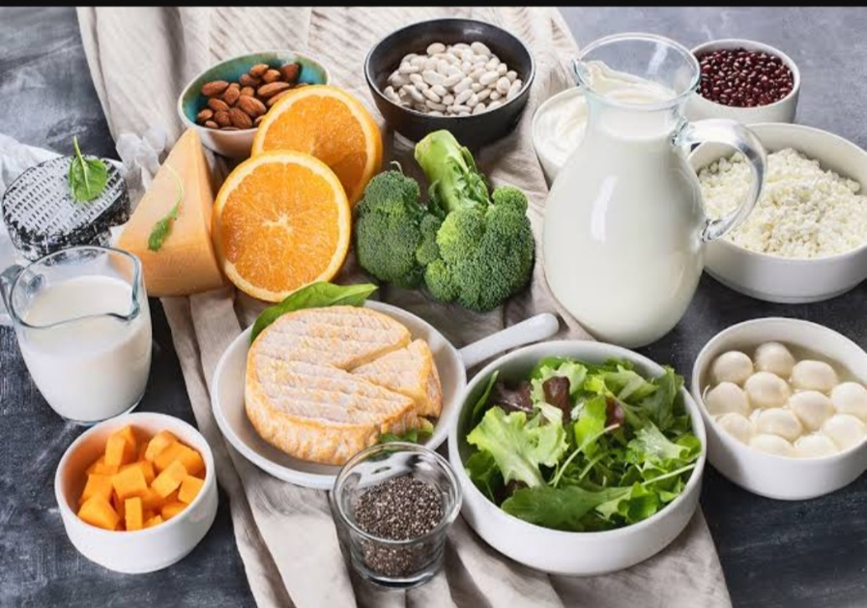

**CALCIUM – AN ESSENTIAL MACROMINERAL**

SUPPORT YOUR BONES TODAY, THEY WILL SUPPORT YOU TOMORROW

A

well balanced diet can help you get the recommended amount of calcium. Consuming enough calcium, directly from dietary sources or as calcium supplements, is essential for proper nutrition.

WHY IS CALCIUM SO IMPORTANT?

Calcium is the structural component of bone, the most abundant mineral. It combines with phosphorus (75% of body’s total min cont.) to form bones and teeth (comprises 99% of body’s calcium). It plays a major role in bone mineralization. It aids in strengthening bones and teeth, helps in muscle contraction and blood clotting as well. Total body calcium reflects the constant interchange of calcium supplied in food or supplements, calcium stored in the skeleton and urinary calcium. The other 1% is distributed in intra and extracellular fluid.

WHAT HAPPENS WHEN CALCIUM LEVELS ARE LOW?

Calcium can be found in the body in bones as well as in blood. Low levels of calcium in the blood lead to the resorption of calcium from the bones into the blood, if the blood calcium levels are not maintained, it leads to continuous resorption which leads to the weakening of bones. Prolonged deficiency of calcium in the body leads to deficiency diseases such as **rickets and tetany**, which occurs as a result of very low calcium levels. **Osteomalacia**, where the newly deposited bone matrix fails to mineralize adequately resulting in the loss of bone stiffness and deformities. **Osteoporosis** which is characterised by low BMD and compromised bone strength, leading to increasing risk of fractures.

HOW MUCH AMOUNT OF CALCIUM IS REQUIRED IN A DAY?

|  |  |
| --- | --- |
| CATAGORY | CALCIUM RDA (mg/dl) |
| MEN | 600 |
| WOMEN  PREGNANCY  LACTATION | 600  1200  1200 |

HOW TO MEET THE REQUIREMENTS?

Calcium is found naturally in number of foods such as **Dairy products** such asmilk, cheese, yogurt, **Sea foods** such as salmon, sardines with bones, clams, oysters**, Vegetables** such asturnip, mustard greens, broccoli, cauliflower, kale **Legumes and legume products** suchas tofu, **Nuts** especially almonds

It is important to emphasize low calorie, low fat, non-fat dairy sources in case of weight control concerns. It is important to emphasize Vitramin-D sources in the diet as Vitamin D increases absorption of calcium from gut.